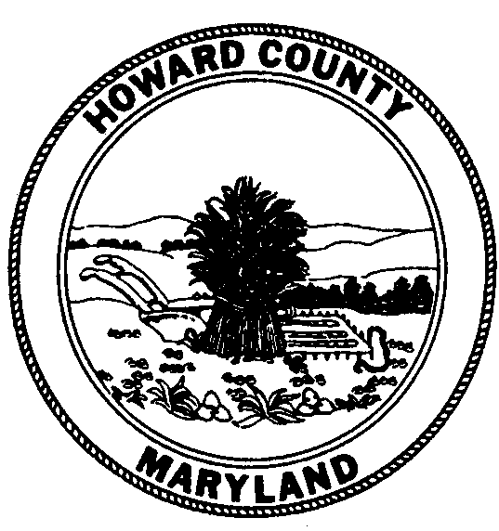
Howard County Council
COUNCILMEMBERS
Calvin Ball, Chairperson
District 2
Courtney Watson, Vice Chairperson
District 1
Jennifer Terrasa
District 3
Mary Kay Sigaty
District 4
Greg Fox
District 5

George Howard Building
3430 Court House Drive
Ellicott City, Maryland 21043-4392

Agenda - Rescheduled

January 18, 2014 – January 31, 2014

County Council
Wednesday, January 22, 2014
Banneker Room
George Howard Building, 3430 Court House Drive, Ellicott City, MD
7:00 p.m.

Public Hearing

The following legislation was introduced by the Chairperson at the request of the County Executive unless otherwise noted:

Appointments

Council Resolution 158-2013 - Confirming the appointment of Vananzo H. Eaton to the Pension Oversight Commission. (tabled 1-6-14)
Council Resolution 1-2014 - Confirming the appointment of Michele Brown to the Board of Directors of the Howard County Mental Health Authority.
Council Resolution 2-2014 - Confirming the appointment of Bruce MacDonald to the Alcohol & Drug Abuse Advisory Board.
Council Resolution 3-2014 - Confirming the appointment of Collin Sullivan to the Howard County Local Children’s Board.
Council Resolution 4-2014 - Confirming the reappointment of Sherman Howell to the Environmental Sustainability Board.
Council Resolution 5-2014 - Confirming the reappointment of Dr. Mark Southerland to the Environmental Sustainability Board.
Council Resolution 6-2014 - Confirming the reappointment of Jeanne M. Zarnoch to the Personnel Board.

General

Council Bill No. 1-2014 (ZRA 147) - AN ACT amending the Howard County Zoning Regulations to amend the Purpose Statement of the TOD District; to provide that the district may allow for certain uses; to allow certain industrial uses, subject to certain criteria; and generally relating to the Howard County Zoning Regulations.
Council Bill No. 2-2014 - AN ACT requiring certain recycling services for certain apartment complexes and condominiums; requiring compliance with the County’s “Apartment and Condominium Recycling Plan”; authorizing certain inspections; providing for certain penalties; and generally related to apartment and condominium recycling in Howard County.
Council Resolution 7-2014 - A RESOLUTION approving an amendment to the Solid Waste Management Plan, 2003-2013, in accordance with the procedure required by State Law.
Council Resolution 8-2014 - Introduced by: Courtney Watson, Co Sponsored by: Calvin Ball, Mary Kay Sigaty, and Jennifer Terrasa - A RESOLUTION, creating a task force to study the issues associated with human trafficking in Howard County, to educate the public about human trafficking, to identify and serve victims of human trafficking, and to increase prosecution of traffickers.
Council Resolution 9-2014 – Introduced by: The Chairperson - A RESOLUTION calling the County Council of Howard County, Maryland into legislative session on specified dates.

Tabled
Council Resolution No. 150-2011 - Introduced by Greg Fox - Proposing to add a section to Article VIII. “Centralized Purchasing” of the Howard County Charter to limit the exercise of the power of eminent domain so that the power is used only for public purposes and not for private economic development, and submitting this amendment to the voters of Howard County for their adoption or rejection in accordance with Article X of the Howard County Charter and Article XIA of the Maryland Constitution. (tabled 10-4-11)
Council Resolution No. 117-2013 - Declaring that a total of approximately 0.841 acres of real property owned by Howard County and identified as a portion of the right-of-way of Dorsey Run Road is no longer needed for a public purpose; authorizing the County Executive to waive the advertising and bidding requirements of Section 4.201 of the Howard County Code in order to convey the property to Coastal Sunbelt Produce; and providing that the County Executive is not bound to convey the property if he finds that the land may have a further public use and submits his finding to the County Council for its consideration. (tabled 10-7-13)
Council Resolution 158-2013 - Confirming the appointment of Vananzo H. Eaton to the Pension Oversight Commission. (tabled 1-6-14)

* * * * * * * * * * * *
County Council
Legislative Work Session
Monday, January 27, 2014
Banneker Room
George Howard Building, 3430 Court House Drive, Ellicott City, MD
4:30 p.m.

Visit the Council’s website (http://cc.howardcountymd.gov) to view legislation, send written testimony, and sign-up electronically to testify at public hearings.
Persons needing accommodations to fully participate in the meeting, please contact the Council Office, 410-313-2001, at least eight working days in advance.

